

**SCHOOL OF COMPUTER SCIENCE AND INFORMATION TECHNOLOGY**

**DEPARTMENT OF INFORMATION TECHNOLOGY**

**PROJECT TITLE: SMART ACCOUNTING APPLICATION (SMARTBIZ)**

**NAME: ONDIEKI CALVIN KUMBA**

**REGISTRATION NUMBER: C025-01-1450/2015**

**SUPERVISOR**

**MR. PATRICK NDUNGU**

**Project documentation submitted to the Department of Information Technology in the school of computer science and Information Technology in partial fulfillment of the requirements for the award of the degree of BSc. in Information Technology at Dedan Kimathi University of Technology**

**November, 2018**

# DECLARATION

I hereby declare that SMART ACCOUNTING Application (smartbiz) is my original work and has never been submitted or presented for any academic purpose in any University or any other institution as a whole or in part except where specifically acknowledged. The contents of this project may be made available for academic purpose.

Name: Ondieki Calvin Kumba

Signature: ……………………… Date: ………………………

This project has been submitted with my approval as the University supervisor, Dedan Kimathi University of Technology.

Name: Mr. Patrick Ndungu

Signature: ……………………… Date: ……………………

# DEDICATION

To my loving parents, Mr. and Mrs. Mareri, for their continuous support without which I would not have discovered my path.

# ACKNOWLEDGEMENT

I acknowledge the Almighty God for guiding me through the whole process of this project development from idea generation to actual project implementation.

I also acknowledge my supervisor, Mr. Patrick Ndungu, for his guidance and continuous support throughout the project.

I wish to acknowledge my friends and family for their prayers and emotional support throughout the process. Special acknowledgements to my parents for their continued support and trust. I could also wish to acknowledge my Sister Ethel Ondieki for the support financial and morally till this time. May the Almighty God bless you abundantly.

# ABSTRACT

Small businesses are always looking for ways to increase revenue. Whether by increasing sales, eliminating redundancies or decreasing internal expenses, organizations are on the lookout for the next big cost-saving measure that will free up valuable cash flow. What many small businesses may never calculate, however, is their business’ profit margin, an essential figure for anyone trying to find ways to increase the bottom line. A company’s profit margin is the easiest and quickest way to tell how efficiently a company uses its resources, and it’s a great tool to gauge a company’s profitability. Profit margin is defined as a ratio of profits earned to total costs over a defined period (e.g. a quarter, a year, etc.). Each industry generally has its own average profit margin due to the differences in costs and materials needed for different products and services.

There are two types of profit margin that small businesses might find useful:

Gross Profit Margin: The gross profit margin equation is typically used to determine the profit margin of a singular product or service, not of an organization as a whole

Net Profit Margin: This is often the equation used to determine an entire organization’s profit margin. Net profit margin is calculated by taking the company’s total sales for a given time period, subtracting total expenses and then dividing that figure by total revenue While it’s useful to know your business’ gross profit margin, we’re going to focus our attention on net profit margin and its uses for business.

# TABLE OF CONTENT

Table of Contents

DECLARATION ii

DEDICATION iii

ACKNOWLEDGEMENT iv

ABSTRACT v

TABLE OF CONTENT vi

LIST OF FIGURES viii

CHAPTER ONE: INTRODUCTION 1

1.1 BACKGROUND OF THE STUDY 1

1.2 PROBLEM STATEMENT 1

1.3 OBJECTIVES 2

1.3.1 General Objectives 2

1.3.2 Specific Objectives 2

1.3 SCOPE OF RESEARCH 2

1.4 ASSUMPTIONS MADE 2

1.5 LIMITATIONS 2

CHAPTER TWO: LITERATURE REVIEW 3

2.1 INTRODUCTION 3

2.2. Case studies 3

2.2.1. Nextar point of sale system 3

2.2.2 SHOPRITE SUPERMARKET MANAGEMENT SYSTEM 4

2.2.3 MegTools Point of Sale System: 4

2.2.4. Paper based system 5

2.3. SUMMARY 5

CHAPTER THREE METHODOLOGY 6

3.1 Introduction 6

3.2 System Development and Methodology 6

3.3 Data Collection Methods 7

3.3.1 Primary data collection methods 7

3.3.2 Secondary data collection methods 7

3.4 Implementation 7

CHAPTER FOUR: SYSTEM ANALYSIS AND DESIGN 8

4.1 Introduction 8

4.2 Requirement analysis 8

4.2.1 Functional Requirements 8

4.2.2 Non-Functional Requirements 8

4.2.3 Hardware and Software Requirements 8

4.2.4 Software Requirements 8

4.2.5 Hardware Requirements 9

4.2.6 Economic Requirements 9

4.2.7 Security Requirements 9

4.3. System Analysis 10

4.3.1. Use Case Diagram 10

4.3.2 Sequence Diagram 11

4.4. System design 13

4.4.1 Flowchart Diagrams 13

4.4.1.1. Flowchart Diagram 14

4.4.2. Data flow diagram 15

4.4.3. Entity Relationship Diagram 16

Figure 4.4.6 ERD 16

4.4.4. Data Analysis Methods and Techniques 17

CHAPTER FIVE: IMPLEMENTATION, DEPLOYMENT AND CHALLENGES 20

5.1 Introduction 20

5.4.4 Test Case 3: Adding product with dates of expiry. 21

5.3.3 Sample result 3: M-pesa transaction Page 24

5.4 Installation 25

5.4 Support and Training 25

5.4 Maintenance 25

CHAPTER SIX: CONCLUSION, LIMITATIONS AND RECOMMENDATION 26

6.1 Conclusion 26

6.2 Limitations. 26

6.3 Recommendation 26

REFERENCES 27

References 27

Appendices 28

Appendix 1: Budget 28

2 :Gantt chart Schedule 28

3:Questionnaires 29

4: Sample code 33

# LIST OF FIGURES

Figure 4.1:Use case Diagram 22

Figure 1: Pie Chart 29

Figure 2: Bar Chart 30

Figure 3: Line Chart 31

# CHAPTER ONE: INTRODUCTION

## BACKGROUND OF THE STUDY

Majority of Kenyans are involved in small scale business. Most of the unemployed persons rely on this small scale business for their livelihood. Small businesses are always looking for ways to increase revenue. Whether by increasing sales, eliminating redundancies or decreasing internal expenses, organizations are on the lookout for the next big cost-saving measure that will free up valuable cash flow. Various businesses collapse simply because they were not managed well.

Small businesses are always looking for ways to increase revenue. Whether by increasing sales, eliminating redundancies or decreasing internal expenses, organizations are on the lookout for the next big cost-saving measure that will free up valuable cash flow.

What many small businesses may never calculate, however, is their business’ profit margin, an essential figure for anyone trying to find ways to increase the bottom line. A company’s profit margin is the easiest and quickest way to tell how efficiently a company uses its resources, and it’s a great tool to gauge a company’s profitability.

Profit margin is defined as a ratio of profits earned to total costs over a defined period (e.g. a quarter, a year, etc.). Each industry generally has its own average profit margin due to the differences in costs and materials needed for different products and services.

## PROBLEM STATEMENT

Kenya’s margin of unemployment compared to those employed is very high leaving most of the Kenyans to rely on self-employment to which most of them prefer small scale businesses. Running this small businesses can incur profits or loses. For one to run a business and sustain the business without incurring loses he/she needs a good cash flow, budget and run the business of a profit not losses.

Small businesses are always looking for ways to increase revenue. Whether by increasing sales, eliminating redundancies or decreasing internal expenses, organizations are on the lookout for the next big cost-saving measure that will free up valuable cash flow. What many small businesses may never calculate, however, is their business’ profit margin, an essential figure for anyone trying to find ways to increase the bottom line. A company’s profit margin is the easiest and quickest way to tell how efficiently a company uses its resources, and it’s a great tool to gauge a company’s profitability.

Profit margin is defined as a ratio of profits earned to total costs over a defined period (e.g. a quarter, a year, etc.). Each industry generally has its own average profit margin due to the differences in costs and materials needed for different products and services.

This application is going to help businessmen/women to calculate the best profit margin that will sustain their business, manage cash flow, create budgets, calculate VAT, automate bill payments, alert you to unusual outgoings and provide a free credit score.

Using online invoices and reminders is also a powerful way to persuade reluctant clients to part with money. Healthy cash flow is a vital part of running a business. It is, literally, the make or break for many business owners who need to stay on top of their finances, especially cash flow, to ensure they can operate successfully. Beyond just a stable operating budget, the real reason business owners create and progress their ventures is because they want to create lasting wealth, driven by profit.

## 1.3 OBJECTIVES

### 1.3.1 General Objectives

This project is aimed at developing an application that will provide accounting functions to small scale businesses. It also keeps track of commodities expiry dates.

### 1.3.2 Specific Objectives

1. To enable the user to do simple accounting and store data of transactions
2. To keep track on the products and stocks available.
3. To keep track of all present commodities and their expiry dates

## SCOPE OF RESEARCH

This system will allow one to enter all commodities bought for resale with their expected expiry dates and then key in all expenses incurred during purchases then after resale key in all the cash obtained and let the system gives back the profit acquired and also it alerts the user on the expiry dates This project is to be developed as an android based application. It is aimed at helping the small scale business to document their products which they are selling, keep track of the sales, alert on expiry dates of products and also provide profitability margin after every sale of commodities. The system is to be simple.

## ASSUMPTIONS MADE

The only assumption made is that every small scale business owner has access to an android phone.

## LIMITATIONS

The project does not carter for large scale business owners it is limited to small scale businesses

# CHAPTER TWO: LITERATURE REVIEW

## 2.1 INTRODUCTION

All around, there are several applications and systems that have been implemented to provide services such related to the small biz application in question. In this chapter we will deal with reviews of the relevant literature and case studies, research gap and methodology of implementation.

Globally, there are several systems that have been implemented that provides services to the business society. This chapter with review of the relevant literature in the business systems and summaries of the case studies.

## **2.2. Case studies**

### 2.2.1. Nextar point of sale system

Provides an easy-to-use barcode scanning system. Just plug it into your computer to start using it in your Point of Sale and Inventory Screens. A barcode scanner can be up to 50% more efficient than the manual process. Use the time you'll be saving to focus on other areas of your business.

Supermarkets usually have all their products in stock before selling them. If by any chance you come across a product that hasn't yet been inventory - don't worry - you can quickly add it during checkout. Just enter a product code/SKU, name and price and it will be automatically added to your inventory.

Some of the most popular reasons for offering products at a discounted price is to boost customer satisfaction, facilitate change or promote package deals. Use the Discounts feature as a negotiation tool. Press a key and enter the amount to be deducted from the sales total right from the checkout screen.

Allow multiple payment methods. Give your customers the freedom to pay with both cash and credit! NEXTAR POS allows you to label and edit every payment method. This feature helps you expedite the accounts receivable process since you can filter transactions by date and payment method. This feature is exclusive to PRO and PREMIUM accounts. This feature was created to give you more flexibility and autonomy in your dealings. Put orders on hold, make other sales and later resume it from where you left off. This tool is also useful when orders are sent to another department before being finalized. These sales will then be saved in your Orders list.

Print a receipt once the sale is completed or send orders to print in another department. Nextar POS offers an easy way to pair your printer to the software, as well as a set of customizable templates. All you have to do is choose the type of printer (standard or coil) and a template.

### 2.2.2 SHOPRITE SUPERMARKET MANAGEMENT SYSTEM

Shoprite is the leading retailer across Africa and is the brand of choice for many consumers across the African continent. Shoprite’s large following of loyal customers can be attributed to their ability to offer the widest range of products and the highest standards of goods and services which is a necessary factor in building a formidable supermarket. Shoprite works hand in hand with many local Eigerian suppliers, buying in bulk in order to pass the cost savings onto you as the customer. So this way, you can continue to enjoy a world class shopping experience whilst saving money. There are series of comparison between the prices of Shoprite and some other lower market which shows the huge standard created by the Supermarket.

### 2.2.3 MegTools Point of Sale System:

MegTools have been studying the forms of business since long. The study resulted in creation of software to deal with every primary and secondary operation of a business. Though the primary operation of every business is to sell and provide service but the secondary operations are different for every form. The Point of Sale System has an entire segment of Grocery POS Software. It not only takes care of the primary operation, but even helps the entrepreneur in managing the secondary operations as well as the accounting and managerial section. Features: Point of Sale System comes with a number of features. The features can be customized as per the size and kind of business. It offers a wide range of accounting practices, according to the standards of IAS (International Accounting Standards) and has a complete section for managerial performances.

It provides: A complete log for sales, which include the recording of sale, printing of sale invoice and summarizing the sales chronologically

It records the purchases and even creates the tabular and graphical presentation of the difference between purchases and sales It helps the HR department in generating the payroll, gratuity, calculation of provident fund and other benefits Manages the shifts of staff Calculates the taxes, as per the provision of the state

Helps in the performance of rebate and special discounts offered in any promotion or deal It is a Cloud VPN, which is not confined to be used within the premises of grocery store over the computers; it can be accessed over multiple devices at a time (whether smartphones or laptops) It creates the profiles for the consumers so that they can order anything using the dashboard of the software and can get it delivered; moreover the profiles can be logged by the admin to learn about the details of the consumers and their likeness, along with their chronological shopping budget

### 2.2.4. Paper based system

Many small scale business currently use a paper-based system to manage the capture and storage of details relating to their products. They calculate their profits and losses and make budget using books and notebooks. The remembrance of the expiry of date is left to the ability of one’s mind to remember the expiry of items.

## 2.3. SUMMARY

From the case studied above, they majorly focus on selling of the products for large scale retailers and supermarkets, this leaves the small scale businesses to depend on outdated methods which are incorrect and may at most times lead to loses in the business. The system will provide a good way to calculate profitability and ensure that the business does not loss products due to the products expiring and without one’s knowledge. This is not considered at all in even large scale businesses.

# CHAPTER THREE METHODOLOGY

## 3.1 Introduction

This section outlines the different methodologies that will be used in developing the system. It will give detail description of the software design methodologies used, data collection methods used, the plan and implementation and the programming languages to be used in development of the proposed system.

It also gives rationale behind the choice of the development process and the technologies.

## 3.2 System Development and Methodology

The proposed system will be developed using incremental development methodology. The idea is to develop the fundamental functionalities of the system first, present the system to the users, then add the other less crucial functionalities incrementally until the system is fully functional as per the specific objectives. This model combines some approaches of waterfall merged with prototyping methodology to come up with a superior hybrid.

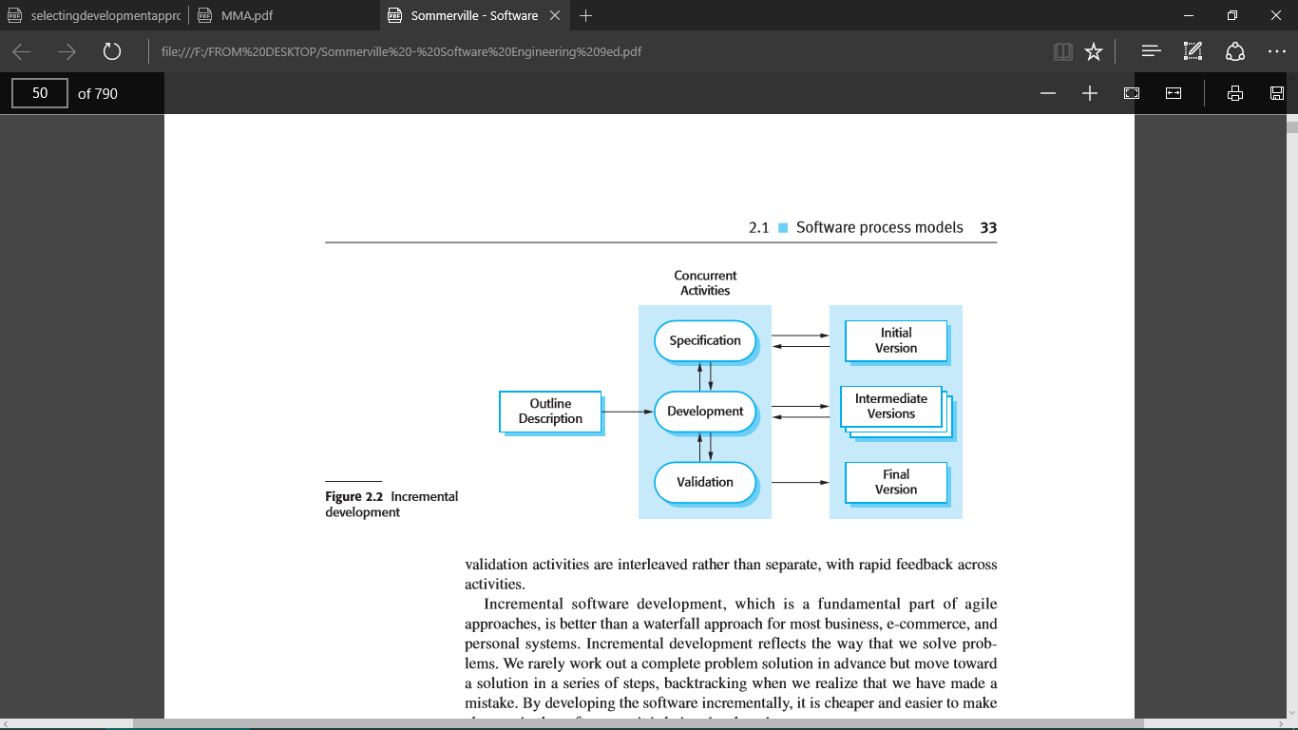

Figure 3.1 Incremental Development Methodology

This approach would be appropriate because, there is a need to build the most important modules of the system first, and then add the rest later as the system stabilizes. The decision to use incremental rather than waterfall or solely prototyping was arrived at, first and foremost, after considering the following advantages among others: -

1. There would be need to exploit knowledge gained in development of early in increments as later increments are being developed.
2. Users will be allowed to test the system at various stages of increments to make sure that it meets the requirements up to that far.
3. It will allow delivery of a series of implementations that are gradually more complete and can go into production more quickly as incremental releases.
4. Gradual implementation would provide the ability to monitor the effect of incremental changes, isolate issues and make adjustments before users change over to the proposed system.

This would make sure that testing is done after every iteration (incremental release). This would mean that identifying bugs and developing of test cases and scenarios would be easier for this system, given its complexity.

## 3.3 Data Collection Methods

Data will be collected from both secondary and primary sources of data

### 3.3.1 Primary data collection methods

#### Questionnaires

A questionnaire is a set of questions for gathering information from individuals. Open questionnaires were administered electronically by email to the business owners

#### Structured Interviews

This is a quantitative research method which aims at ensuring that each interview is presented with exactly same questions and in the same order.

Structured interviews were conducted to various famers on the challenges they face as fur as animal health management is concerned

#### Observation

This method involves gathering of primary data by investigator’s own direct observation of relevant people, actions and situations without asking from the respondent. It has been observed that many small scale business owners do not have a system to keep track of the daily business transactions and keep track of their perishable goods

### 3.3.2 Secondary data collection methods

Some data was collected from articles, documents, journals and online articles

## 3.4 Implementation

The desktop based application will be developed using java platform.

The database technology to be used is MySQL database and apache application server. Database transactions will be implemented using Structured Query Language.

# CHAPTER FOUR: SYSTEM ANALYSIS AND DESIGN

## **4.1 Introduction**

This chapter gives details on the analysis and design of the smart accounting system. System requirements and design are discussed. The system requirements provide the functional and Non-functional requirements of the System. Design of the system is carried out according to the features and operations of the system which includes the user interface, database schemas, code and other documentation. Designing of the system mainly focuses on the user and ensures the System will be user friendly and interactive.

## **4.2 Requirement analysis**

### **4.2.1 Functional Requirements**

The application should be able to perform the following functions:

1. User account registration.
2. User can be able to add the customers and transactions.
3. User can store transactions
4. User can update a single transaction
5. User can search in the database the name of transactions
6. User can generate expiration dates
7. User can update items with expiration date
8. Uses can calculate and do totals on the transactions.
9. User can calculate the profit margin

### **4.2.2 Non-Functional Requirements**

1. Ease to use: The application is easy to use by all type of users.
2. Understandable: The System is easy to understand by new users as it contains very user-friendly interfaces.
3. Availability: The System works 24 hours a day making it convenient for users to access it at any time.
4. Security: The System enhances data authentication by use of passwords to protect it from unauthorized users.
5. Confidentiality: The System ensures confidentiality of users’ information.
6. Reliability: Minimum meantime to failure, low probability of unavailability and rate of failure occurrence, it should be available at all times.

### **4.2.3 Hardware and Software Requirements**

The proposed application will we be web based.

### **4.2.4 Software Requirements**

This web application requires:

1. WampServer
2. Android Studio
3. Firebase
4. Git repository.
5. Microsoft office 2016 and above used in documentation and slide presentation for purpose of presentation.
6. Windows OS- important as it was the platform for the software to run on.
7. Antivirus-to help protect files against external attacks and malware.
8. Web browser- for access web contents important for research in application development.

### **4.2.5 Hardware Requirements**

1. Minimum of 80 GB external hard disk.
2. Power supply.
3. Modem/internet connection.
4. Laptop.

### **4.2.6 Economic Requirements**

If the proposed System will be implemented, one will need an internet-enabled device to enable online storage of data and transactions.

### **4.2.7 Security Requirements**

Security and control over the data is necessary in creating an application. This is to minimize the threat of unauthorized access.

## 4**.3. System Analysis**

In this phase, one does the analysis of the data that was collected in the previous phase and put it in a way that it’s easier to automate, best done by a diagrammatical representation of the information. For this project we will use the UML modelling language because it’s a visual language that assists one to analyze and design Systems.

### **4.3.1. Use Case Diagram**

The diagram shows the actors and the use cases and the relationship between the two. It is a diagrammatical representation of how the Admin, Students and the Alumni will interact with the System in order to make the communication efficient, reliable, and affordable.

Figure 4.1:Use case Diagram



Figure 4.1.1:: Use case Diagram 2

addaa

user

sign in

Add item

Add transaction and accounts

Update date

Update items transaction

Search

Import, backup data

Log out

### **4.3.2 Sequence Diagram**

They illustrate how messages are sent and received between objects and the sequence of

Message transfer. It also details how operations are carried out according to the time of operation.

CLASSES

* User
* interface
* transactions
* purchase
* search
* backup

MESSAGES

* Invalid data
* Data backed up
* Create a purchase
* Create transaction

UML sequence diagrams model the flow of logic within your System in a visual manner, enabling you both to document and validate your logic, and are commonly used for both analysis and design purposes.

A sequence diagram shows, as parallel vertical lines, different processes or objects that live simultaneously, and, as horizontal arrows, the messages exchanged between them, in the order in which they occur.

Figure 4.2: Sequence Diagram

User

Interface

transaction

purchase

Upload details

View uploads and do totals

Send thread

View threads

Post transactions in full

Approve purchases and post its totals

View posts

Approve account

Figure 4.2: Sequence Diagram

## **4.4. System design**

### **4.4.1** **Flowchart Diagrams**

A flowchart is a type of [diagram](http://en.wikipedia.org/wiki/Diagram) that represents an [algorithm](http://en.wikipedia.org/wiki/Algorithm) or [process](http://en.wikipedia.org/wiki/Process_%28science%29), showing the steps as boxes of various kinds, and their order by connecting them with arrows. This diagrammatic [representation](http://en.wikipedia.org/wiki/Knowledge_representation_and_reasoning) illustrates a solution to a given [problem](http://en.wikipedia.org/wiki/Problem_solving). The diagram below shows the flow chart for the System.

Figure 4.3: Flowchart Diagrams 1



### **4.4.1.1. Flowchart Diagram**

Figure 4.4 : Flow chart

start

login

User Logged in?

Enter transaction,

View generated reports

Update records

Compute the totals

Receive alerts on expiration dates

STOP

NO

NO

YES

YES

Enter items and expiration date

Store items

YES

### **4.4.2. Data flow diagram**

This is a graphical representation of the flow of data through an information System. I will use a data flow diagram to visualize on data processing in my proposed project. Further, I will use it to develop a conceptual picture of the interaction between the System and outside entities.

Figure 4.5: Data flow diagram

Users

Smart accounting System

D

Users

Edit transactions.

Enter transactions and items plus date of expiration

View transactions

Approve users and provide transaction reports and notifications

p

### **4.4.3. Entity Relationship Diagram**

An ERD diagram showed the relationships of entity sets stored in the database.

### Figure 4.4.6 ERD

Email

user

Name

Transaction

Credit

Date

Debit

Items

### **4.4.4. Data Analysis Methods and Techniques**

|  |  |  |  |  |
| --- | --- | --- | --- | --- |
| Number of Respondents | Satisfied | Not Satisfied | Not Sure |  |
| 40 | 36 | 3 | 1 |  |

Table 1: Overall Respondents Table

Percentage of resident with small scale business who were satisfied with the smart accounting application= 36/40*100=90%

Percentage of resident with small scale business who were not satisfied with the smart accounting application =3/40*100=7.5%

Percentage of smart accounting application who were not sure about the System to be developed=1/40*100=2.5%

Below are the graphical interfaces to clearly indicate the results received from the questionnaires: -

Figure 1: Pie Chart

We can clearly conclude that majority of the respondents liked the application.

Figure 2: Bar Chart

Figure 3: Line Chart

We can clearly conclude that majority of the respondents liked the application. From the bar, pie and line chart analysis above, it was clear that most people were satisfied with the smart accounting being introduced.

# CHAPTER FIVE: IMPLEMENTATION, DEPLOYMENT AND CHALLENGES

### 5.1 Introduction

As a dual function, software testing is used to ascertain the defects in program and it is used to assist in judging whether a program is usable in practice or not. With this regards, software testing is used for validation and the verification which in turn ensure that the software conforms to its specification and meets the customer or rather the user needs.

There are various types of testing that have been used in testing the developed system.

Figure 5.1: test step

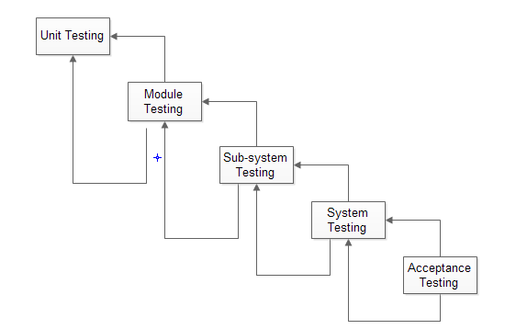

**Unit testing**: the unit testing warrants that each component works independently of one another, that is, as a single unit. This includes ensuring a successful user log in for authorized uses, entering the property details as well as modifying them

**Integration Testing**: This testing is paramount in meeting the systems functionality objectives. In this testing, once the property owner or any other user is registered into the system, his or her details are reflected in the database instantaneously.

**System Testing**: This was done after integrating all modules and running the whole system to verify if it meets the functional and non-functional requirements.

**Acceptance Testing**: This is done prior to deploying the system to a live environment. It is done using specified inputs into the system and verifies that the resulting outputs are correct, without knowing the internal workings of the system.

5.2 Test Cases During the system development, tests were carried out to determine the workability of the system. Some of these tests include

5.2.1 Test Case 1: User Registration and Login For the registration, the inputs include: the username which is to be viewed in the profile details of the registered user, email and also the password, which later are used t authenticate the user during any login attempts made.

Expected results: after a successful registration or login attempt, the home page of the application is loaded, which then showcases added real estate property added by other users. Otherwise, if the registration or login attempt fails, a toast is displayed alerting the user, and thus will not proceed to the homepage.

Status: Test passed.

5.2.2 Test Case 2: adding transaction details

. Procedure: the user enters the transaction tab and add details of the transaction including name, price and amount the user via a link is transferred to the Mpesa platform to which he/she will be able to pay services and receive a notification of the transaction

Status: Test passed

. 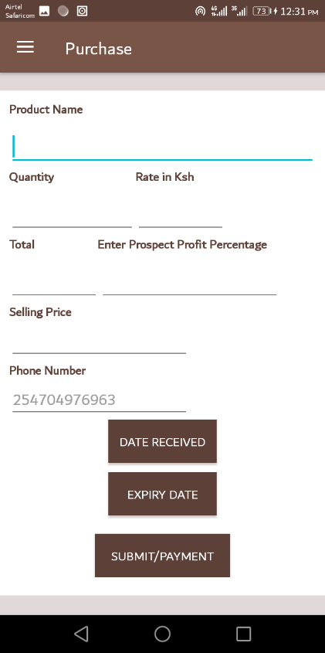

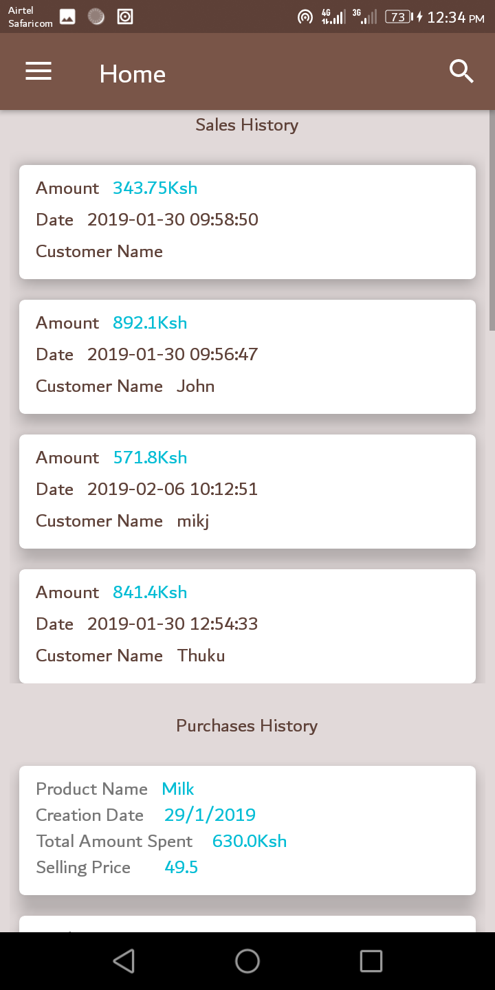

### 5.4.4 Test Case 3: Adding product with dates of expiry.

Procedure: the user enter the product tabs then he/she chooses add product. He /she specifies the product in mind then adds the price and the date of expiry. The product is added to the stock and can be viewed via the stock tab.

 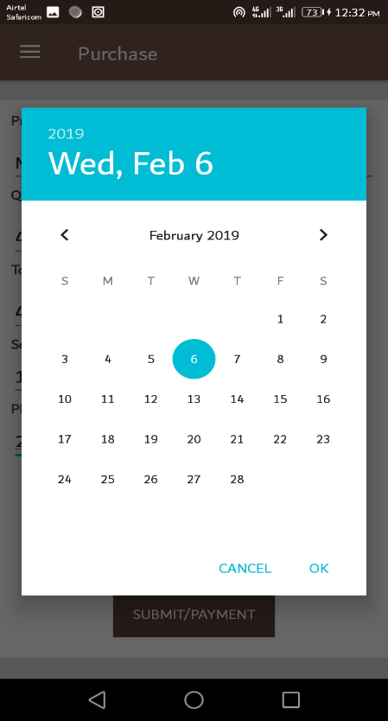

Status: Passed

5.3 Sample Results/User Interface and system Features. The following show cases the systems User interface.

5.3.1 Sample result 1: Registration and sign in

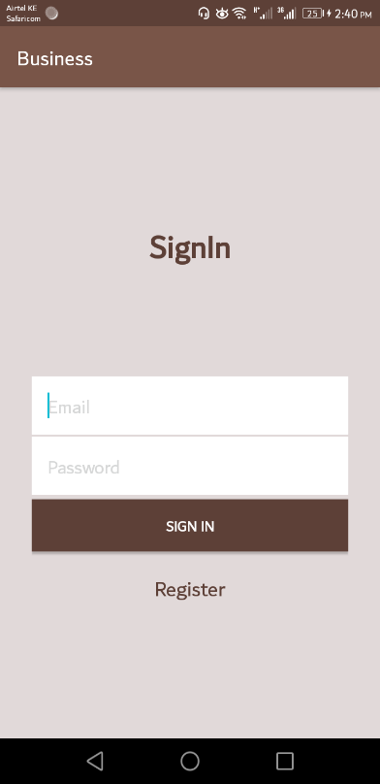

.

A first time user will need to be registered with the system first. When a user is registered, he or she can then sign in to the system using the sign in module after which they are directed to the home page of the application

5.3.2 Sample result 2: Home Page

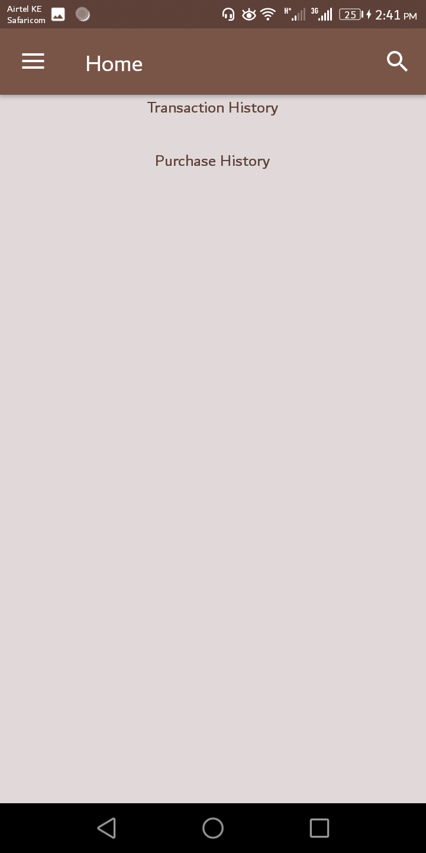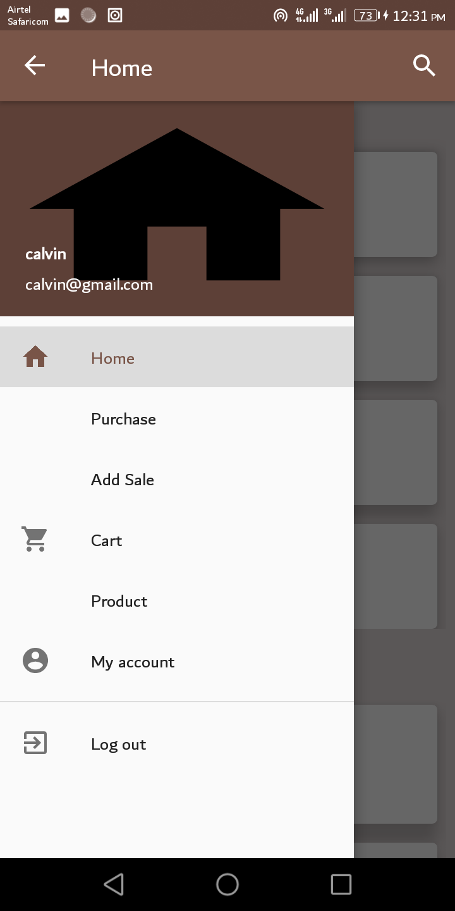

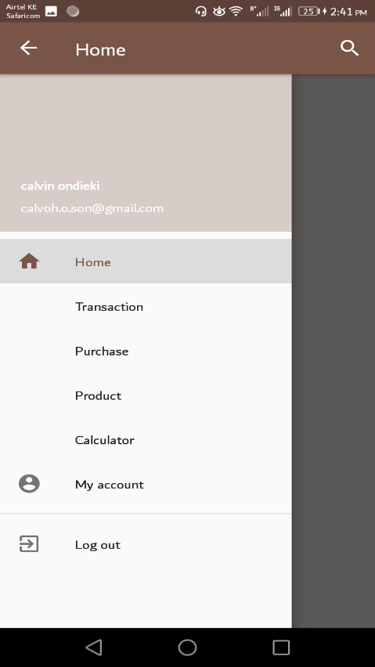

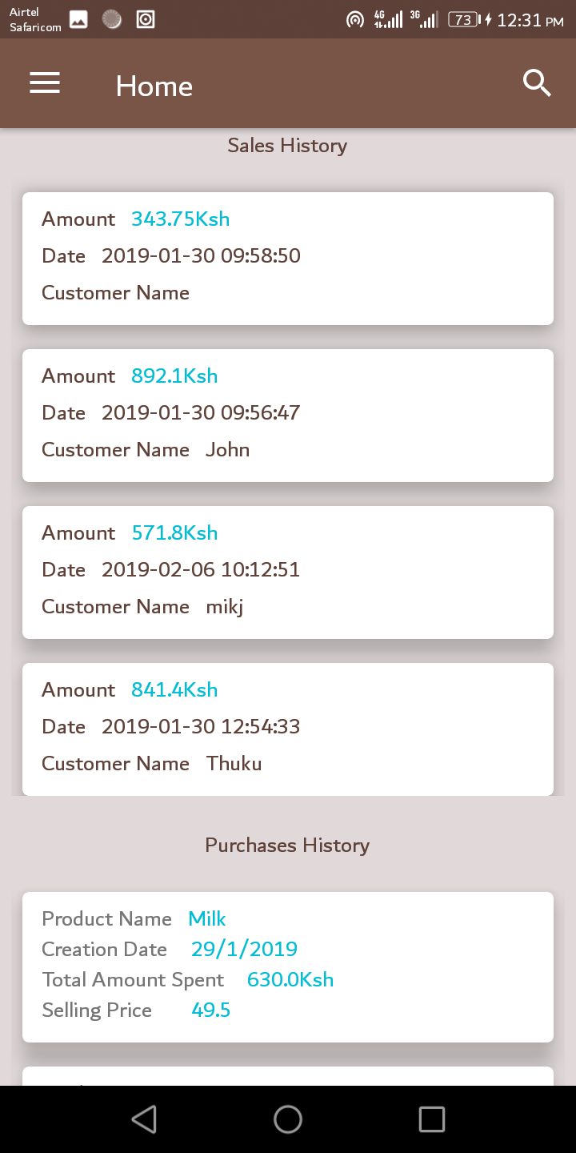

### 5.3.3 Sample result 3: M-pesa transaction Page

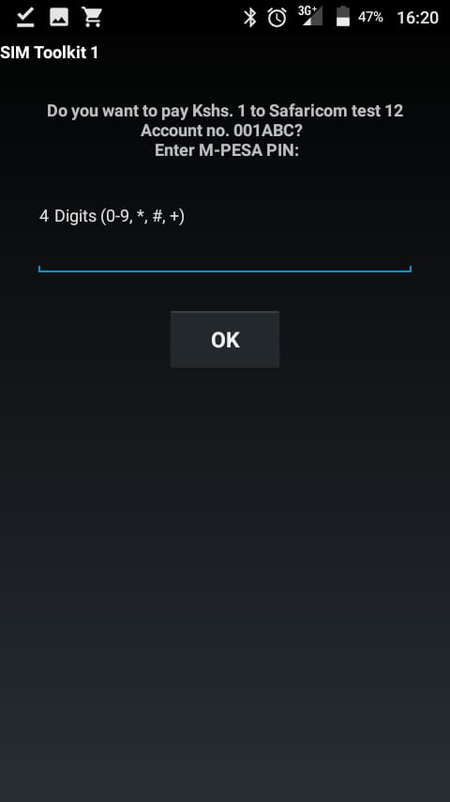

5.3.4 Sample result 4: stock view page

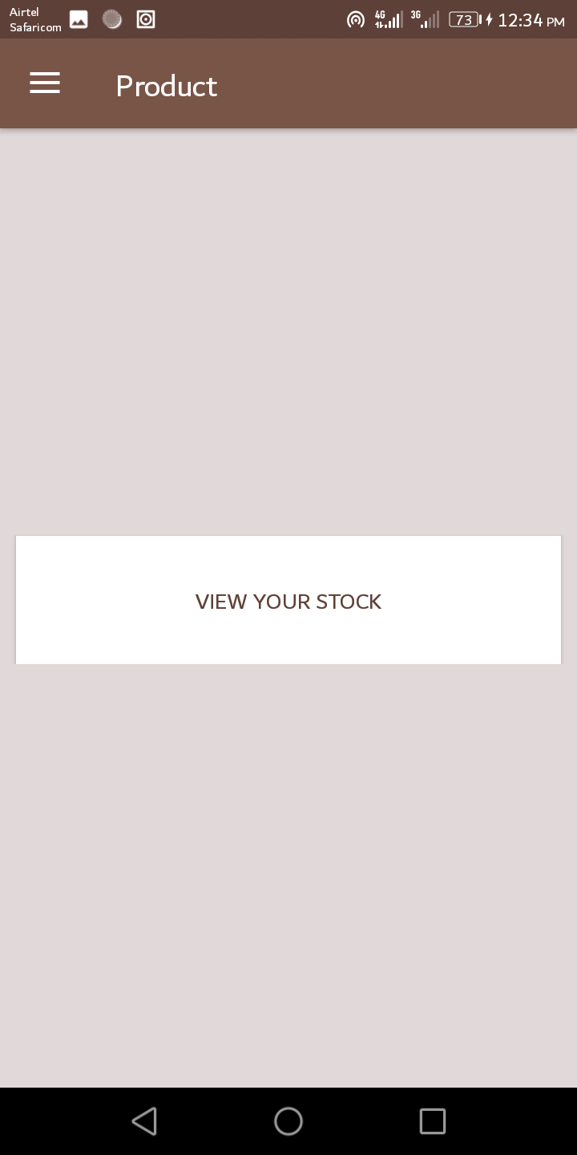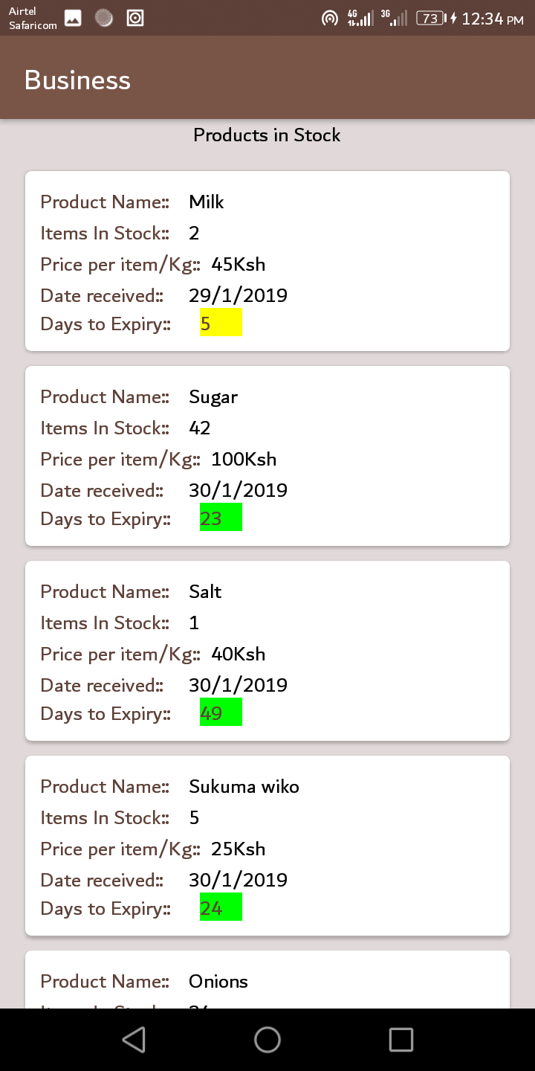

The home page showcases the recent transactions by the users of the system.it also provides link to transaction tabs, user login details, calculator, products, purchases and account within the application.

### 5.4 Installation

This application being an android application has an easy installation procedure as assisted by android interface application installation guidelines for regular users of android.

### 5.4 Support and Training

Since the application is meant to be used by the general public, it has been made as an easy application to use requiring minimal to no training at all for a first time user.

### 5.4 Maintenance

The fact that the application is using a newly introduced platform in the field of IT, the application will regularly be updated to support the new releases and libraries that will updated so as to work more efficiently and also to provide additional features in the future that are useful to this domain.

# CHAPTER SIX: CONCLUSION, LIMITATIONS AND RECOMMENDATION

### 6.1 Conclusion

An android smart accounting application system was developed to enhance the traditional manner of

Accounting for the small scale business owners which has been a burden as technology improves and lack of skills in terms of management of small scale business.

This system is designed to make the management and accounting in small businesses much easier, reliable, efficient, convenient and accurate.

Also with the technology it reduces the efforts and time spent to do manual management and making accounting records thus bring about the comfort of users, and enhances productivity.

### 6.2 Limitations.

The various challenges or limitations faced during this exercise include:

Lack of resources. The project required finances and resources in terms of necessary resources such as paid API keys for instance the google API used in the project.

Challenges in adapting to new changes and updates in the programming ide used. This is with regards to the platform used. Android studio generally has a number of updates to which require time a reliable internet speed to accomplish the required update.

Unreliable internet access. The project required extensive research which more than often involved use of the school internet which was not really reliable. Also the project required internet connectivity so as to perform its operations as expected • Handling and implementing the logic in customizing the system to suit the scope of its usage.

Uncooperative respondents during data collection. Some didn’t want to answer questions while others were reluctant in providing some information required for the research. This hampered the data collection process.

Time constraints. There wasn’t enough time for collecting data, analyzing it, system design, and development and testing considering I did this system along with my studies.

### 6.3 Recommendation

Future researchers may add the following to their future research work:

An ordering module to the system.

A payment module to enable payment from the customers to the user in the system

A feature that enables customers to view the products available in stock.

# REFERENCES

## References

Ferreira, K. J., & Goh, J. (2015). Intermediation in the Supply of Agricultural Products in Developing Economies, (Rapsomanikis), 2.

GoK. (2015). *Agricultural Sector Development Strategy; 2010-2020*. *Government of Kenya Issue*.

Karugu, W. (2010). Kenya Agricultural Commodity Exchange ( KACE ): Linking small ­ scale farmers to markets. *GIM Case Study No. B068*, 1.

Kenya Agricultural Commodity Exchange. (2018, June). In *Wikipedia*.

MFARM Ltd, Kenya | FARMD: Forum for Agricultural Risk Management in Development. (n.d.).

Mukhebi, A. (2004). KENYA AGRICULTURAL COMMODITY EXCHANGE LIMITED ( KACE ) Reaching the Poor in Rural Kenya with Market Information : A Case Study of a Market Information System A Paper for presentation at the CTA Seminar 2004 on the Role of Information Tools in Adrian Mukhe. *A Paper for Presentation at the CTA Seminar 2004 on the Role of Information Tools in Food Security, Maputo, Mozambique*, 1–20.

Scenario, C. (n.d.). 2016-063 Res Rep IDC5 Transforming agr.

Tsekouropoulos, G., Andreopoulou, Z., Koliouska, C., Lefa, S., Koutroumanidis, T., & Batzios, C. (2011). E-marketing and Internet Functions of Agricultural Products in SME in Greece. *CEUR Workshop Proceedings*, *1152*(Haicta 2011), 213–224.

## Appendices

### Appendix 1 Budget

|  |  |
| --- | --- |
| **Resources** | **Cost Estimation in KS** |
| Personal Computer | 40,000.00 |
| Android Studio | 0.00 |
| Code Editors | 0.00 |
| Stationery | 500.00 |
| Internet Connection | 2,500.00 |
| Power | 500.00 |
| **Total in KS** | 44,500.00 |
|  |  |

## 2**: Gantt chart Schedule**

|  |  |  |  |  |  |  |  |  |
| --- | --- | --- | --- | --- | --- | --- | --- | --- |
| Tasks | Durations in months | | | | | | | |
| 1 | 2 | 3 | 4 | 5 | 6 | 7 | 8 |
| Proposal  Writing |  |  |  |  |  |  |  |  |
| Analysis |  |  |  |  |  |  |  |  |
| Design |  |  |  |  |  |  |  |  |
| Coding |  |  |  |  |  |  |  |  |
| Testing |  |  |  |  |  |  |  |  |
| Documentation |  |  |  |  |  |  |  |  |
| Final presentation |  |  |  |  |  |  |  |  |

### 

### 3: Questionnaires

Letter of Introduction

Date: ………………….

**Dear Sir/ Madam,**

**Re: Research on the automation of small business accounting**

I am a student at Dedan Kimathi University of technology pursuing a Degree in B.Sc. Information Technology. Attached is a copy of a questionnaire that will be used in collecting information from you for the study required. The information you give will be considered as a personal view and total confidentiality will be observed.

Kindly respond to all items in the questionnaire and to the best of your knowledge.

Your response will be highly appreciated.

Thanks in advance.

**Yours faithfully,**

**Ondieki Calvin Kumba**

Below is a data collection Questionnaire sample which I used to Collect Data from the small scale business owner around Nyeri and its environs

Dear respondent,

Please fill in the required details. Indicate your answer by checking (icon06) the appropriate box of choice. Your assistance is highly appreciated. Thank you.

1. **Do you have access to an android phone?**

Yes

No

**If so, how often?**

Daily

Weekly

Monthly

1. **Do you have skills basic skill to operate an android phone?**

Yes

No

**Are you able to interact with English language in your phone?**

Yes

No

**If not, do you have a person who can assist on android and English related explanations?**

Outsource personnel

Request assistance from family members

Others, (*Please explain*)

........................................................................................................................................................................................................................................................................................................................

1. **Do you see the need of automating the accounting aspect of your small scale business?**
2. Yes

No

**If No, why?**

I do not trust digital devices.

I am comfortable with the current system

I see no need developing that system

Others, (*Please Explain*)

**…………………………………………………………………………………………………………………………………………………………………………………………………….**

**…………………………………………………………………………………………………**

1. **What other technical equipment’s devices do you operate in your day to day activity? (*Tick a****s* ***many options as po****s****sible)***

Telephone

Smart phone

Scanners

Printer**s**

Laptop

Tablet

Others (*please indicate)*

**…………………………………………………………………………………………………………………………………………………………………………………………………….**

1. **What functions would you like the Smart Accounting System to perform?**

Store data

Facilitate a back up

Ease of retrieval of data

Print transactions

Facilitate an effective payment system

Others, (*Please specify*)

**…………………………………………………………………………………………………………………………………………………………………………………………………….**

1. **Should the system contain login permission for the users to enhance data security?**

Yes

No

**If No, why?**

One can forget the pa**ss**word

It I hard to login

To avoid wastage of time

It i**s** too Westernized, African not used to it

Others (*Please specify)*

**…………………………………………………………………………………………………………………………………………………………………………………………………….**

1. **What type of output would you like the Smart Accounting System to give?**

Generate transactional reports

Notify time of expiry of commodities

Others (*Please specify)*

**………………………………………………………………………………………………………………………………………………………………………………………………………………**

1. **How do you think the new system will improve business performance? (*You can make more than one selection.)***

Increased efficiency

Increased integrity

Enhanced data security

Increased effectiveness

Others (*please indicate below)*

**……………………………………………………………………………………………………………………………………………………………………………………… …………….**

1. **Are you prepared to embrace the development of the new system?**

Yes

No

Others, (*Please specify***………………………………………………………………………………………………………………………………………………………………………………………………**

1. **What are the anticipated challenges with the development of a new system?**

Literacy level

Scarce resources (android pones etc.)

Others**, (**Please *specify*)

**............................................................................................................................................................................................................................................................................................................**

### 4: Sample code

package com.example.developer.calvin;  
  
import android.content.Intent;  
import android.content.SharedPreferences;  
import android.support.design.widget.Snackbar;  
import android.support.v7.app.AppCompatActivity;  
import android.os.Bundle;  
import android.util.Log;  
import android.view.View;  
import android.widget.Button;  
import android.widget.EditText;  
  
import com.android.volley.AuthFailureError;  
import com.android.volley.Request;  
import com.android.volley.Response;  
import com.android.volley.VolleyError;  
import com.android.volley.toolbox.StringRequest;  
import com.android.volley.toolbox.Volley;  
import com.example.developer.calvin.Adapters.HomeAdapter;  
import com.example.developer.calvin.Fragments.HomeFragment;  
import com.example.developer.calvin.Models.Home;  
  
import org.json.JSONArray;  
import org.json.JSONException;  
import org.json.JSONObject;  
  
import java.util.HashMap;  
import java.util.Map;  
  
import static com.example.developer.calvin.Constants.Url.*DELETE_TRANSACTION*;  
import static com.example.developer.calvin.Constants.Url.*GET_PURCHASES*;  
import static com.example.developer.calvin.Constants.Url.*GET_TRANSACTION_DETAILS*;  
import static com.example.developer.calvin.Constants.Url.*UPDATE_TRANSACTION_*;  
  
public class TransactionEditActivity extends AppCompatActivity {  
 EditText edCustomerName, edCustomerAddress, edAmount, edDate,edRemark;  
 Button bnUpdate,bnDelete;  
 SharedPreferences sharedPreferences;  
 String name,address,amount,date,remark,TransactionId;  
 Bundle bundle;  
 Snackbar snackbar;  
 @Override  
 protected void onCreate(Bundle savedInstanceState) {  
 super.onCreate(savedInstanceState);  
 setContentView(R.layout.*activity_transaction_edit*);  
  
 edCustomerName = findViewById(R.id.*edCustomerName*);  
 edCustomerAddress = findViewById(R.id.*edCustomer_Address*);  
 edAmount = findViewById(R.id.*edAmount*);  
 edDate = findViewById(R.id.*edDate*);  
 edRemark = findViewById(R.id.*edRemark*);  
 bnDelete = findViewById(R.id.*bnDelete*);  
 bnUpdate = findViewById(R.id.*bnUpdate*);  
 bundle = getIntent().getExtras();  
 TransactionId = String.*valueOf*(bundle.getInt("transaction_id"));  
 Log.*i*("con",""+TransactionId);  
  
 loadTransactionDetails();  
 bnUpdate.setOnClickListener(new View.OnClickListener() {  
 @Override  
 public void onClick(View view) {  
 updateTransaction();  
 }  
 });  
  
 bnDelete.setOnClickListener(new View.OnClickListener() {  
 @Override  
 public void onClick(View view) {  
 deleteTransaction();  
 }  
 });  
 }  
  
 private void loadTransactionDetails() {  
 StringRequest stringRequest = new StringRequest(Request.Method.*POST*, *GET_TRANSACTION_DETAILS*,  
 new Response.Listener<String>() {  
 @Override  
 public void onResponse(String response) {  
 Log.*i*("conn", "" + response);  
 try {  
 JSONArray jsonArray = new JSONArray(response);  
 for (int i = 0; i < jsonArray.length(); i++) {  
 JSONObject jsonObject = jsonArray.getJSONObject(i);  
  
 name = jsonObject.getString("customer_name");  
 address = jsonObject.getString("customer_address");  
 amount = jsonObject.getString("amount");  
 date = jsonObject.getString("transaction_date");  
 remark = jsonObject.getString("remarks");  
 }  
 edCustomerName.setText(name);  
 edCustomerAddress.setText(address);  
 edAmount.setText(amount);  
 edDate.setText(date);  
 edRemark.setText(remark);  
 } catch (JSONException e) {  
 e.printStackTrace();  
 }  
  
 }  
 }, new Response.ErrorListener() {  
 @Override  
 public void onErrorResponse(VolleyError error) {  
  
 }  
 }) {  
 @Override  
 protected Map<String, String> getParams() throws AuthFailureError {  
 Map<String, String> params = new HashMap<>();  
 params.put("transaction_id", TransactionId);  
 return params;  
 }  
 };  
 Volley.*newRequestQueue*(getApplicationContext()).add(stringRequest);  
 }  
  
  
 public void updateTransaction(){  
  
 StringRequest stringRequest = new StringRequest(Request.Method.*POST*, *UPDATE_TRANSACTION_*,  
 new Response.Listener<String>() {  
 @Override  
 public void onResponse(String response) {  
 Log.*i*("conn",""+response);  
 if (response.equals("Transaction successfully updated")){  
 showSnackbar(response);  
 Intent intent = new Intent(getApplicationContext(), DashBoardActivity.class);  
 startActivity(intent);  
 }else{  
 showSnackbar(response);  
 }  
 }  
 }, new Response.ErrorListener() {  
 @Override  
 public void onErrorResponse(VolleyError error) {  
  
 }  
 }){  
 @Override  
 protected Map<String, String> getParams() throws AuthFailureError {  
 SharedPreferences sharedPreferences = getSharedPreferences("MyPref",*MODE_PRIVATE*);  
 Map<String, String> params = new HashMap<>();  
 params.put("transaction_id", TransactionId);  
 params.put("customer_name", edCustomerName.getText().toString().trim());  
 params.put("customer_address", edCustomerAddress.getText().toString().trim());  
 params.put("amount", edAmount.getText().toString().trim());  
 params.put("user_id", sharedPreferences.getString("user_id",""));  
 params.put("remarks", edRemark.getText().toString().trim());  
 return params;  
 }  
 };  
 Volley.*newRequestQueue*(getApplicationContext()).add(stringRequest);  
 }  
  
 public void deleteTransaction(){  
 StringRequest stringRequest = new StringRequest(Request.Method.POST, DELETE_TRANSACTION,  
 new Response.Listener<String>() {  
 @Override  
 public void onResponse(String response) {  
 Log.i("conn",""+response);  
 if (response.equals("Transaction successfully deleted.")){  
 edCustomerName.setText("");  
 edCustomerAddress.setText("");  
 edAmount.setText("");  
 edRemark.setText("");  
 edDate.setText("");  
 edRemark.setText("");  
 showSnackbar(response);  
 Intent intent = new Intent(getApplicationContext(),DashBoardActivity.class);  
 startActivity(intent);  
 }else{  
 showSnackbar(response);  
 }  
 }  
 }, new Response.ErrorListener() {  
 @Override  
 public void onErrorResponse(VolleyError error) {  
  
 }  
 }){  
 @Override  
 protected Map<String, String> getParams() throws AuthFailureError {  
 Map<String, String> params = new HashMap<>();  
 params.put("transaction_id", TransactionId);  
 return params;  
 }  
 };  
 Volley.*newRequestQueue*(getApplicationContext()).add(stringRequest);  
 }  
  
 public void showSnackbar(String stringSnackbar){  
 snackbar.make(findViewById(android.R.id.content), stringSnackbar.toString(), Snackbar.LENGTH_SHORT)  
 .setActionTextColor(getResources().getColor(R.color.colorPrimary))  
 .show();  
 }  
}